1. **Understanding Problem**
2. Goal

My goal is to make the program to pass the three steps. The first step is that the program asks the user to enter the number of diners. Then the second step is that the program asks the diner to choose the menu. Finally, the last step is that the program shows the menu that diners had selected and calculates the cost of the dinner.

1. Assumption

I assume that the valid range of party size I will permit will be 1~25.

I assume that diner will not change his/her order.

I assume that diners can order the same dish.

I assume that the items will be listed separately on the bill.

I assume that the bill will ask the user to write a tip, and calculate the final cost of the dinner.

1. Program Setting

Restaurant Theme: Beef Steak House

Number of items on the menu: 4

Menu 1) Tenderloin Steak Price: $15.85

Menu 2) Sirloin Steak Price: $14.65

Menu 3) T-bone Steak Price: $21.75

Menu 4) Tomahawk Steak Price: $30.55

Including a tip.

1. **Devise a plan**

**<int main()>**

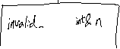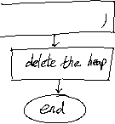

**<void invalid_size(int& n)>**

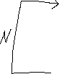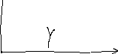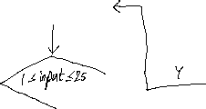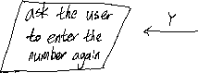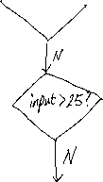

**<float* menu(string arr1[],float arr2[],int* a)>**

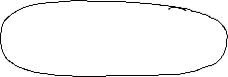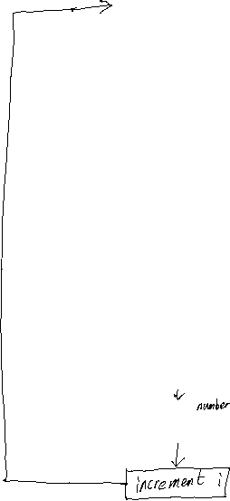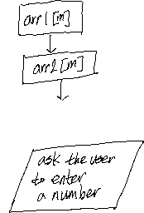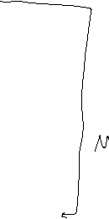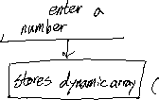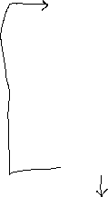

**<void sum_menu(int*n, float arr[])>**

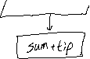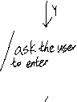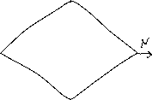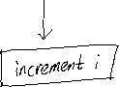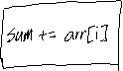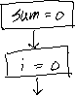

**Strategy**

I predict that it will take about four hours to implement this program. First of all, I will set the static array to demonstrate the menu and the price. Secondly, I will make a function that determines the invalid size of the party and allow the user to fix it. When the function is completed, I will use a function to create a dynamic array that stores the price of the food. After the dynamic array works, I will make a function that calculates the bill and asks the user to give a tip or not. If the user decide to give a tip, it will print out total amount that is sum of the total price of the dinner and the tip. If the user decide not to give a tip, it will print out the total price of the dinner.

**3.Test Cases**

|  |  |  |
| --- | --- | --- |
| **Setting** | **User Input** | **Expected Result** |
| Welcome to the Steak House Restaurant!  How many diners in your party(1~25)? | 0 | Invalid size; Please enter a number between 1 and 25: |
| Welcome to the Steak House Restaurant!  How many diners in your party(1~25)? | 100 | Invalid size; Please enter a number between 1 and 25: |
| Welcome to the Steak House Restaurant!  How many diners in your party(1~25)? | 3 | Diner 1, please make your choice:  1)Tenderloin Steak: $15.85  2) Sirloin Steak: $14.65  3) T-bone Steak: $21.75  4) Tomahawk Steak: $30.55  Enter: |
| Diner 1, please make your choice:  1)Tenderloin Steak: $15.85  2) Sirloin Steak: $14.65  3) T-bone Steak: $21.75  4) Tomahawk Steak: $30.55  Enter: | 4 | Diner 2, please make your choice:  1)Tenderloin Steak: $15.85  2) Sirloin Steak: $14.65  3) T-bone Steak: $21.75  4) Tomahawk Steak: $30.55  Enter: |
| Diner 2, please make your choice:  1)Tenderloin Steak: $15.85  2) Sirloin Steak: $14.65  3) T-bone Steak: $21.75  4) Tomahawk Steak: $30.55  Enter: | 2 | Diner 3, please make your choice:  1)Tenderloin Steak: $15.85  2) Sirloin Steak: $14.65  3) T-bone Steak: $21.75  4) Tomahawk Steak: $30.55  Enter: |
| Diner 3, please make your choice:  1)Tenderloin Steak: $15.85  2) Sirloin Steak: $14.65  3) T-bone Steak: $21.75  4) Tomahawk Steak: $30.55  Enter: | 1 | I hope your dinner was delicious!  Do you want to give a tip (y/n)? |